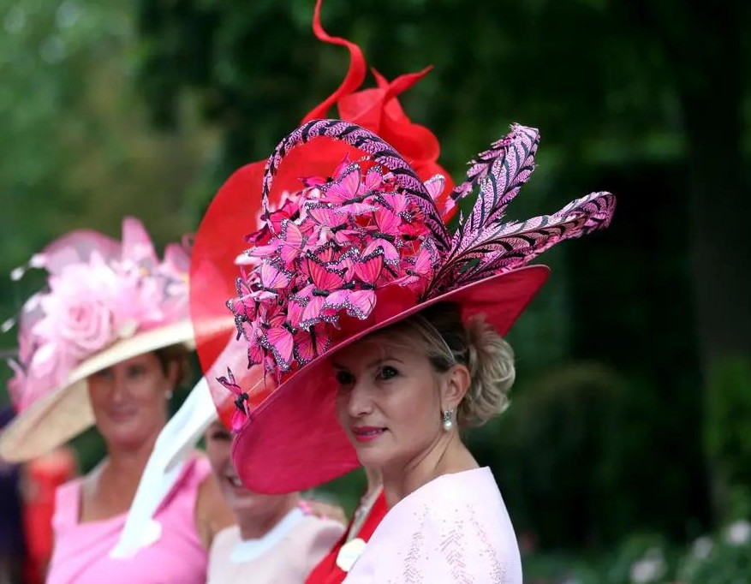

THE EBRANA CELEBRATION HAT

At every important celebration, the people of Ebrana wear a classy hat. The higher and more ornate it is, the more wealth and fortune the person in question has. You can therefore clearly see who belongs to the nobility and who is more of a middle class by the material, weight and length of the hat.

PRODUCT

Each inhabitant is responsible for his/her own hat, most hats are handmade by the inhabitants themselves. But there are also specialised milliners in Ebrana who, for a fee, will create the hat you want.

PLACE

Before an important celebration takes place, many milliners display beautiful hats in their shop windows to convince the inhabitants to order a hat from them. They also use leaflets in mailboxes to create awareness.

PROMOTION

The price of hats varies; those belonging to a higher class naturally wear hats of excellent quality and more expensive materials. The ordinary citizen pays on average 150 Brana’s for the basic hat, additional decoration depends on the individual.

PRICE